**Database Design Project 25**

**Student: Turcu Gabriel**

**CEN4.S**

**Teacher: Liana Stănescu**

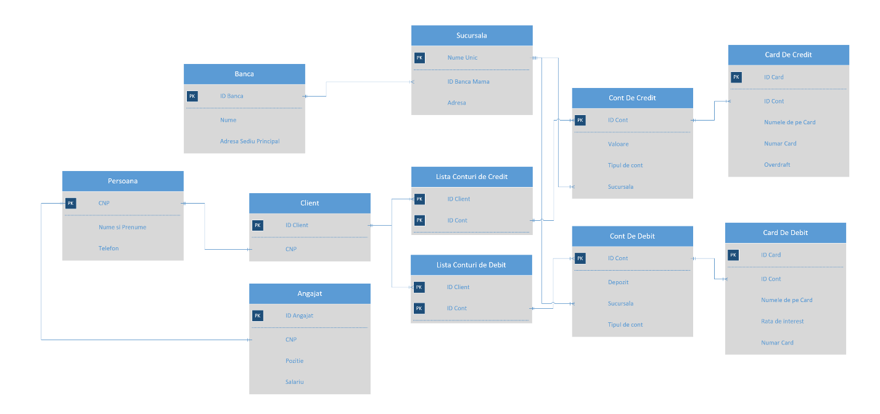**Diagrams**

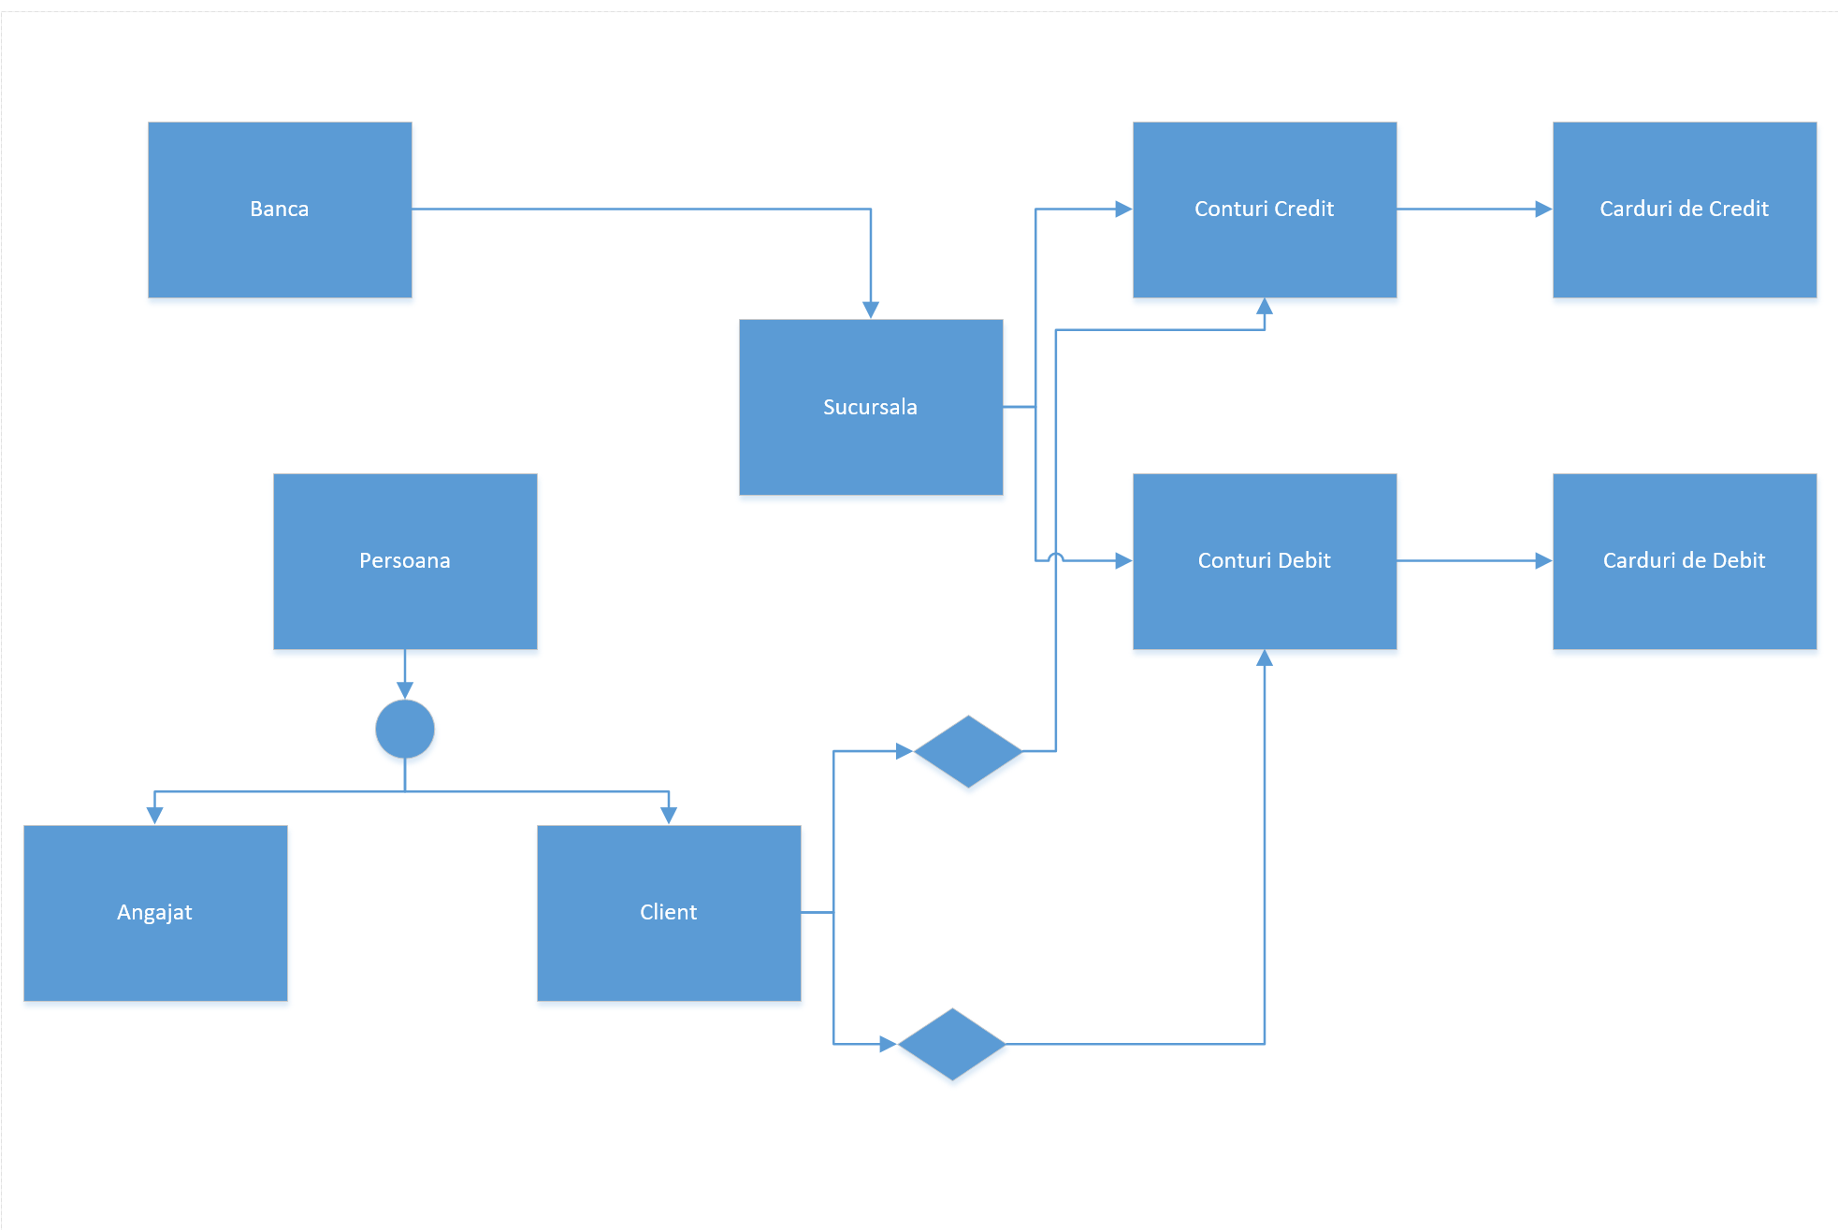

**Create Statements**

**Angajat:**

CREATE TABLE "ANGAJAT"

( "ID_ANGAJAT" NUMBER,

"CNP" NUMBER,

"POZITIE" VARCHAR2(30),

"SALARIU" NUMBER,

CONSTRAINT "ANGAJAT_PK" PRIMARY KEY ("ID_ANGAJAT") ENABLE

) ;ALTER TABLE "ANGAJAT" ADD CONSTRAINT "ANGAJAT_FK" FOREIGN KEY ("CNP")

REFERENCES "PERSOANA" ("CNP") ENABLE;

CREATE OR REPLACE TRIGGER "BI_ANGAJAT"

before insert on "ANGAJAT"

for each row

begin

if :NEW."ID_ANGAJAT" is null then

select "ANGAJAT_SEQ".nextval into :NEW."ID_ANGAJAT" from dual;

end if;

end;

/

ALTER TRIGGER "BI_ANGAJAT" ENABLE;

**Banca:**

CREATE TABLE "BANCA"

( "ID_BANCA" NUMBER,

"NUME" VARCHAR2(30),

"ADRESA_SEDIU_PRINCIPAL" VARCHAR2(500),

CONSTRAINT "BANCA_PK" PRIMARY KEY ("ID_BANCA") ENABLE

) ;

CREATE INDEX "BANCA_IDX1" ON "BANCA" ("ID_BANCA", "NUME")

;

CREATE OR REPLACE TRIGGER "BI_BANCA"

before insert on "BANCA"

for each row

begin

if :NEW."ID_BANCA" is null then

select "BANCA_SEQ".nextval into :NEW."ID_BANCA" from dual;

end if;

end;

/

ALTER TRIGGER "BI_BANCA" ENABLE;

**Card De Credit:**

CREATE TABLE "CARD_DE_CREDIT"

( "ID_CARD" NUMBER,

"ID_CONT" NUMBER,

"NUMELE_DE_PE_CARD" VARCHAR2(30),

"NUMAR_CARD" NUMBER,

"OVERDRAFT" NUMBER,

CONSTRAINT "CARD_DE_CREDIT_PK" PRIMARY KEY ("ID_CARD") ENABLE

) ;ALTER TABLE "CARD_DE_CREDIT" ADD CONSTRAINT "CARD_DE_CREDIT_FK" FOREIGN KEY ("ID_CONT")

REFERENCES "CONT_DE_CREDIT" ("ID_CONT") ENABLE;

CREATE OR REPLACE TRIGGER "BI_CARD_DE_CREDIT"

before insert on "CARD_DE_CREDIT"

for each row

begin

if :NEW."ID_CARD" is null then

select "CARD_DE_CREDIT_SEQ".nextval into :NEW."ID_CARD" from dual;

end if;

end;

/

ALTER TRIGGER "BI_CARD_DE_CREDIT" ENABLE;

**Card De Debit:**

CREATE TABLE "CARD_DE_DEBIT"

( "ID_CARD" NUMBER,

"ID_CONT" NUMBER,

"NUMELE_DE_PE_CARD" VARCHAR2(30),

"RATA_DE_INTEREST" NUMBER,

"NUMAR_CARD" NUMBER,

CONSTRAINT "CARD_DE_DEBIT_PK" PRIMARY KEY ("ID_CARD") ENABLE

) ;ALTER TABLE "CARD_DE_DEBIT" ADD CONSTRAINT "CARD_DE_DEBIT_FK" FOREIGN KEY ("ID_CONT")

REFERENCES "CONT_DE_DEBIT" ("ID_CONT") ENABLE;

CREATE OR REPLACE TRIGGER "BI_CARD_DE_DEBIT"

before insert on "CARD_DE_DEBIT"

for each row

begin

if :NEW."ID_CARD" is null then

select "CARD_DE_DEBIT_SEQ".nextval into :NEW."ID_CARD" from dual;

end if;

end;

/

ALTER TRIGGER "BI_CARD_DE_DEBIT" ENABLE;

**Client:**

CREATE TABLE "CLIENT"

( "ID_CLIENT" NUMBER,

"CNP" NUMBER,

CONSTRAINT "CLIENT_PK" PRIMARY KEY ("ID_CLIENT") ENABLE

) ;ALTER TABLE "CLIENT" ADD CONSTRAINT "CLIENT_FK" FOREIGN KEY ("CNP")

REFERENCES "PERSOANA" ("CNP") ENABLE;

CREATE INDEX "CLIENT_IDX1" ON "CLIENT" ("ID_CLIENT", "CNP")

;

CREATE OR REPLACE TRIGGER "BI_CLIENT"

before insert on "CLIENT"

for each row

begin

if :NEW."ID_CLIENT" is null then

select "CLIENT_SEQ".nextval into :NEW."ID_CLIENT" from dual;

end if;

end;

/

ALTER TRIGGER "BI_CLIENT" ENABLE;

**Cont De Credit:**

CREATE TABLE "CONT_DE_CREDIT"

( "ID_CONT" NUMBER,

"VALOARE" NUMBER,

"TIPUL_DE_CONT" VARCHAR2(30),

"SUCURSALA" VARCHAR2(30),

CONSTRAINT "CONT_DE_CREDIT_PK" PRIMARY KEY ("ID_CONT") ENABLE

) ;ALTER TABLE "CONT_DE_CREDIT" ADD CONSTRAINT "CONT_DE_CREDIT_FK" FOREIGN KEY ("SUCURSALA")

REFERENCES "SUCURSALA" ("NUME_UNIC") ENABLE;

CREATE OR REPLACE TRIGGER "BI_CONT_DE_CREDIT"

before insert on "CONT_DE_CREDIT"

for each row

begin

if :NEW."ID_CONT" is null then

select "CONT_DE_CREDIT_SEQ".nextval into :NEW."ID_CONT" from dual;

end if;

end;

/

ALTER TRIGGER "BI_CONT_DE_CREDIT" ENABLE;

**Cont De Debit:**

CREATE TABLE "CONT_DE_DEBIT"

( "ID_CONT" NUMBER,

"DEPOZIT" NUMBER,

"SUCURSALA" VARCHAR2(30),

"TIPUL_DE_CONT" VARCHAR2(30),

CONSTRAINT "CONT_DE_DFBIT_PK" PRIMARY KEY ("ID_CONT") ENABLE

) ;ALTER TABLE "CONT_DE_DEBIT" ADD CONSTRAINT "CONT_DE_DFBIT_FK" FOREIGN KEY ("SUCURSALA")

REFERENCES "SUCURSALA" ("NUME_UNIC") ENABLE;

CREATE OR REPLACE TRIGGER "BI_CONT_DE_DFBIT"

before insert on "CONT_DE_DEBIT"

for each row

begin

if :NEW."ID_CONT" is null then

select "CONT_DE_DFBIT_SEQ".nextval into :NEW."ID_CONT" from dual;

end if;

end;

/

ALTER TRIGGER "BI_CONT_DE_DFBIT" ENABLE;

CREATE OR REPLACE TRIGGER "CONT_DE_DEBIT_T1"

BEFORE

insert on "CONT_DE_DEBIT"

for each row

begin

:new.depozit := :new.depozit +10;

end;

/

ALTER TRIGGER "CONT_DE_DEBIT_T1" ENABLE;

**Lista Conturi De Credit:**

CREATE TABLE "LISTA_CONTURI_DE_CREDIT"

( "ID_CLIENT" NUMBER,

"ID_CONT" NUMBER,

CONSTRAINT "LISTA_CONTURI_DE_CREDIT_PK" PRIMARY KEY ("ID_CLIENT", "ID_CONT") ENABLE

) ;ALTER TABLE "LISTA_CONTURI_DE_CREDIT" ADD CONSTRAINT "LISTA_CONTURI_DE_CREDIT_FK" FOREIGN KEY ("ID_CLIENT")

REFERENCES "CLIENT" ("ID_CLIENT") ENABLE;ALTER TABLE "LISTA_CONTURI_DE_CREDIT" ADD CONSTRAINT "LISTA_CONTURI_DE_CREDIT_FK2" FOREIGN KEY ("ID_CONT")

REFERENCES "CONT_DE_CREDIT" ("ID_CONT") ENABLE;

**Lista Conturi de Debit:**

CREATE TABLE "LISTA_CONTURI_DE_DEBIT"

( "ID_CLIENT" NUMBER,

"ID_CONT" NUMBER,

CONSTRAINT "LISTA_CONTURI_DE_DEBIT_PK" PRIMARY KEY ("ID_CLIENT", "ID_CONT") ENABLE

) ;ALTER TABLE "LISTA_CONTURI_DE_DEBIT" ADD CONSTRAINT "LISTA_CONTURI_DE_DEBIT_FK2" FOREIGN KEY ("ID_CONT")

REFERENCES "CONT_DE_DEBIT" ("ID_CONT") ENABLE;ALTER TABLE "LISTA_CONTURI_DE_DEBIT" ADD CONSTRAINT "LISTA_CONTURI_DE_DEBIT_FK3" FOREIGN KEY ("ID_CLIENT")

REFERENCES "CLIENT" ("ID_CLIENT") ENABLE;

**Persoana:**

CREATE TABLE "PERSOANA"

( "CNP" NUMBER,

"NUME_SI_PRENUME" VARCHAR2(50),

"TELEFON" VARCHAR2(15),

CONSTRAINT "PERSOANA_PK" PRIMARY KEY ("CNP") ENABLE

) ;

CREATE OR REPLACE TRIGGER "BI_PERSOANA"

before insert on "PERSOANA"

for each row

begin

if :NEW."CNP" is null then

select "PERSOANA_SEQ".nextval into :NEW."CNP" from dual;

end if;

end;

/

ALTER TRIGGER "BI_PERSOANA" ENABLE;

**Sucursala:**

CREATE TABLE "SUCURSALA"

( "NUME_UNIC" VARCHAR2(30),

"ID_BANCA_MAMA" NUMBER,

"ADRESA" VARCHAR2(500),

CONSTRAINT "SUCURSALA_PK" PRIMARY KEY ("NUME_UNIC") ENABLE

) ;ALTER TABLE "SUCURSALA" ADD CONSTRAINT "SUCURSALA_FK" FOREIGN KEY ("ID_BANCA_MAMA")

REFERENCES "BANCA" ("ID_BANCA") ENABLE;

CREATE OR REPLACE TRIGGER "BI_SUCURSALA"

before insert on "SUCURSALA"

for each row

begin

if :NEW."NUME_UNIC" is null then

select "SUCURSALA_SEQ".nextval into :NEW."NUME_UNIC" from dual;

end if;

end;

/

ALTER TRIGGER "BI_SUCURSALA" ENABLE;

**Queries:**

1. **Lista detalii Angajati**

select "PERSOANA"."NUME_SI_PRENUME" as "NUME_SI_PRENUME",

"PERSOANA"."TELEFON" as "TELEFON",

"ANGAJAT"."ID_ANGAJAT" as "ID_ANGAJAT",

"ANGAJAT"."CNP" as "CNP",

"ANGAJAT"."POZITIE" as "POZITIE",

"ANGAJAT"."SALARIU" as "SALARIU"

from "ANGAJAT" "ANGAJAT",

"PERSOANA" "PERSOANA"

where "ANGAJAT"."CNP"="PERSOANA"."CNP"

1. **Lista detalii Credite**

select "SUCURSALA"."NUME_UNIC" as "NUME_UNIC",

"CONT_DE_CREDIT"."TIPUL_DE_CONT" as "TIPUL_DE_CONT",

"CONT_DE_CREDIT"."VALOARE" as "VALOARE"

from "CONT_DE_CREDIT" "CONT_DE_CREDIT",

"SUCURSALA" "SUCURSALA"

where "CONT_DE_CREDIT"."SUCURSALA"="SUCURSALA"."NUME_UNIC"

1. **Lista Angajati care sunt si Clienti**

select "CLIENT"."ID_CLIENT" as "ID_CLIENT",

"PERSOANA_2"."CNP" as "CNP",

"ANGAJAT_1"."ID_ANGAJAT" as "ID_ANGAJAT",

"PERSOANA_2"."NUME_SI_PRENUME" as "NUME_SI_PRENUME"

from "ANGAJAT" "ANGAJAT_1",

"CLIENT" "CLIENT",

"PERSOANA" "PERSOANA_2"

where "PERSOANA_2"."CNP"="ANGAJAT_1"."CNP"

and "PERSOANA_2"."CNP"="CLIENT"."CNP"

1. **Informatii sucursale**

select "SUCURSALA"."NUME_UNIC" as "NUME_UNIC",

"BANCA"."NUME" as "NUME",

"SUCURSALA"."ADRESA" as "ADRESA"

from "SUCURSALA" "SUCURSALA",

"BANCA" "BANCA"

where "BANCA"."ID_BANCA"="SUCURSALA"."ID_BANCA_MAMA"

1. **Lista carduri de credit la BRD Craiova**

select "CARD_DE_CREDIT"."ID_CONT" as "ID_CONT",

"CARD_DE_CREDIT"."ID_CARD" as "ID_CARD",

"CARD_DE_CREDIT"."NUMELE_DE_PE_CARD" as "NUMELE_DE_PE_CARD",

"CONT_DE_CREDIT"."SUCURSALA" as "SUCURSALA",

"CARD_DE_CREDIT"."NUMAR_CARD" as "NUMAR_CARD"

from "CARD_DE_CREDIT" "CARD_DE_CREDIT",

"CONT_DE_CREDIT" "CONT_DE_CREDIT"

where "CARD_DE_CREDIT"."ID_CONT"="CONT_DE_CREDIT"."ID_CONT"

and "CONT_DE_CREDIT"."SUCURSALA" = 'BRD Craiova'

1. **Suma totala credite acordate**

select sum(CONT_DE_CREDIT.VALOARE) as "VALOARE"

from "LISTA_CONTURI_DE_CREDIT" "LISTA_CONTURI_DE_CREDIT",

"CONT_DE_CREDIT" "CONT_DE_CREDIT",

"CLIENT" "CLIENT"

where "CLIENT"."ID_CLIENT"="LISTA_CONTURI_DE_CREDIT"."ID_CLIENT"

and "CONT_DE_CREDIT"."ID_CONT"="LISTA_CONTURI_DE_CREDIT"."ID_CONT"

1. **Lista personae cont de debit si cont de credit**

select "CLIENT_1"."CNP" as "CNP",

"CONT_DE_CREDIT"."SUCURSALA" as "SUCURSALA",

"CONT_DE_DEBIT"."SUCURSALA" as "SUCURSALA",

"PERSOANA"."NUME_SI_PRENUME" as "NUME_SI_PRENUME",

"CONT_DE_DEBIT"."ID_CONT" as "ID_CONT",

"CONT_DE_CREDIT"."ID_CONT" as "ID_CONT"

from "LISTA_CONTURI_DE_DEBIT" "LISTA_CONTURI_DE_DEBIT",

"LISTA_CONTURI_DE_CREDIT" "LISTA_CONTURI_DE_CREDIT",

"CONT_DE_DEBIT" "CONT_DE_DEBIT",

"CONT_DE_CREDIT" "CONT_DE_CREDIT",

"CLIENT" "CLIENT_1",

"PERSOANA" "PERSOANA"

where "CLIENT_1"."ID_CLIENT"="LISTA_CONTURI_DE_CREDIT"."ID_CLIENT"

and "CLIENT_1"."ID_CLIENT"="LISTA_CONTURI_DE_DEBIT"."ID_CLIENT"

and "CONT_DE_CREDIT"."ID_CONT"="LISTA_CONTURI_DE_CREDIT"."ID_CONT"

and "LISTA_CONTURI_DE_DEBIT"."ID_CONT"="CONT_DE_DEBIT"."ID_CONT"

1. **Group by conturi de debit pe fiecare sucursala**

select count(SUCURSALA_1.NUME_UNIC) as "NUME_UNIC",

"CONT_DE_DEBIT"."SUCURSALA" as "SUCURSALA"

from "CONT_DE_DEBIT" "CONT_DE_DEBIT",

"SUCURSALA" "SUCURSALA_1"

where "CONT_DE_DEBIT"."SUCURSALA"="SUCURSALA_1"."NUME_UNIC"

group by SUCURSALA_1.NUME_UNIC

1. **Info conturi debit cu dobanda 15%**

select "CONT_DE_DEBIT"."ID_CONT" as "ID_CONT",

"CONT_DE_DEBIT"."DEPOZIT" as "DEPOZIT",

"CONT_DE_DEBIT"."SUCURSALA" as "SUCURSALA",

"CONT_DE_DEBIT"."TIPUL_DE_CONT" as "TIPUL_DE_CONT"

from "CONT_DE_DEBIT" "CONT_DE_DEBIT"

where "CONT_DE_DEBIT"."TIPUL_DE_CONT" ='Dobanda 15%'

1. **Info credite peste 10.000**

select "CONT_DE_CREDIT"."ID_CONT" as "ID_CONT",

"CONT_DE_CREDIT"."VALOARE" as "VALOARE",

"CONT_DE_CREDIT"."TIPUL_DE_CONT" as "TIPUL_DE_CONT",

"CONT_DE_CREDIT"."SUCURSALA" as "SUCURSALA"

from "CONT_DE_CREDIT" "CONT_DE_CREDIT"

where "CONT_DE_CREDIT"."VALOARE" >=10000

1. **Informatii credite de nevoi**

select "CONT_DE_CREDIT"."ID_CONT" as "ID_CONT",

"CONT_DE_CREDIT"."VALOARE" as "VALOARE",

"CONT_DE_CREDIT"."TIPUL_DE_CONT" as "TIPUL_DE_CONT",

"CONT_DE_CREDIT"."SUCURSALA" as "SUCURSALA"

from "CONT_DE_CREDIT" "CONT_DE_CREDIT"

where "CONT_DE_CREDIT"."TIPUL_DE_CONT" ='Credit de nevoi'

1. **Informatii conturi ale caror carduri au overdraft peste 5000**

select "CARD_DE_CREDIT"."ID_CARD" as "ID_CARD",

"CARD_DE_CREDIT"."NUMELE_DE_PE_CARD" as "NUMELE_DE_PE_CARD",

"CARD_DE_CREDIT"."NUMAR_CARD" as "NUMAR_CARD",

"CARD_DE_CREDIT"."OVERDRAFT" as "OVERDRAFT",

"CONT_DE_DEBIT"."DEPOZIT" as "DEPOZIT",

"CONT_DE_DEBIT"."SUCURSALA" as "SUCURSALA",

"CONT_DE_DEBIT"."TIPUL_DE_CONT" as "TIPUL_DE_CONT"

from "CONT_DE_DEBIT" "CONT_DE_DEBIT",

"CARD_DE_CREDIT" "CARD_DE_CREDIT"

where "CONT_DE_DEBIT"."ID_CONT"="CARD_DE_CREDIT"."ID_CONT"

and "CARD_DE_CREDIT"."OVERDRAFT" >5000

1. **Count group by dobanda la contul de debit**

select "CONT_DE_DEBIT"."TIPUL_DE_CONT" as "TIPUL_DE_CONT",

count(CONT_DE_DEBIT.ID_CONT) as "ID_CONT"

from "CONT_DE_DEBIT" "CONT_DE_DEBIT"

group by CONT_DE_DEBIT.TIPUL_DE_CONT

1. **Full outer join info angajati**

select "CLIENT"."ID_CLIENT" as "ID_CLIENT",

"PERSOANA_2"."CNP" as "CNP",

"ANGAJAT_1"."ID_ANGAJAT" as "ID_ANGAJAT",

"PERSOANA_2"."NUME_SI_PRENUME" as "NUME_SI_PRENUME"

from "ANGAJAT" "ANGAJAT_1",

"CLIENT" "CLIENT",

"PERSOANA" "PERSOANA_2"

where "PERSOANA_2"."CNP"="ANGAJAT_1"."CNP"(+)

and "PERSOANA_2"."CNP"="CLIENT"."CNP"(+)

1. **Lista Info Conturi de Credit cu Right Inner Join pe Carduri de Credit**

select "CARD_DE_CREDIT"."ID_CONT" as "ID_CONT",

"CARD_DE_CREDIT"."ID_CARD" as "ID_CARD",

"CARD_DE_CREDIT"."NUMELE_DE_PE_CARD" as "NUMELE_DE_PE_CARD",

"CONT_DE_CREDIT"."SUCURSALA" as "SUCURSALA",

"CARD_DE_CREDIT"."NUMAR_CARD" as "NUMAR_CARD",

"CONT_DE_CREDIT"."ID_CONT" as "ID_CONT"

from "CARD_DE_CREDIT" "CARD_DE_CREDIT",

"CONT_DE_CREDIT" "CONT_DE_CREDIT"

where "CONT_DE_CREDIT"."ID_CONT"="CARD_DE_CREDIT"."ID_CONT"(+)

and "CONT_DE_CREDIT"."SUCURSALA" = 'BRD Craiova'

**Procedures:**

**Procedure 1(Add an employee’s salary to an account):**

create or replace procedure "ADDSALARYTOACCOUNT"  
(employeeid IN NUMBER,  
idcontdebit IN NUMBER)  
is  
    rez number;  
    salary number;  
begin  
SELECT salariu into salary FROM ANGAJAT WHERE id_angajat = employeeid;  
SELECT depozit into rez FROM cont_de_debit WHERE id_cont=idcontdebit;  
dbms_output.put_line('Valoarea depozitului inainte de adaugarea salariului este:'||rez);  
rez := rez+ salary;  
dbms_output.put_line('Valoarea depozitului dupa adaugarea salariului este:'||rez);  
UPDATE cont_de_debit  
SET depozit = rez  
WHERE id_cont=idcontdebit;  
end;​

**Procedure 2(Add yearly interest to an account):**

create or replace procedure "ADDYEARLYINTERESTTOACCOUNT"  
(idcont IN NUMBER)  
is  
    rez number;  
begin  
rez := CALCULATEINTERESTAFTERNYEARS(idcont,0);  
dbms_output.put_line('Depozitul inainte de adaos: '|| rez);   
rez := CALCULATEINTERESTAFTERNYEARS(idcont,1);  
dbms_output.put_line('Depozitul dupa adaos: '|| rez);  
UPDATE cont_de_debit  
SET depozit = rez  
WHERE id_cont=idcont;  
end;​

**Functions:**

**Function 1(Calculate interest sum after N years):**

create or replace function "CALCULATEINTERESTAFTERNYEARS"  
      
(idcont in NUMBER,  
nryears in NUMBER)  
return NUMBER  
is  
    sum_c number;  
    tip VARCHAR2(30);  
    rez number;  
begin  
  
  
SELECT depozit, tipul_de_cont into sum_c, tip FROM CONT_DE_DEBIT WHERE id_cont = idcont;  
  
  
IF tip = 'Dobanda 10%' THEN  
   rez := sum_c + nryears * 0.1 * sum_c;  
ELSE IF tip = 'Dobanda 15%' THEN  
    rez := sum_c + nryears * 0.15 * sum_c;  
ELSE IF tip = 'Dobanda 5%' THEN  
    rez := sum_c + nryears * 0.05 * sum_c;  
END IF;  
END IF;  
END IF;  
  
RETURN rez;  
end;

​**Function 2(Calculate yearly salary of an employee):**

create or replace function "CALCULATEYEARLYSALLARY"  
(employeeid in NUMBER)  
return NUMBER  
is  
    rez number;  
    salary number;  
begin  
SELECT salariu into salary FROM ANGAJAT WHERE id_angajat = employeeid;  
  
rez:= salary *12;  
  
RETURN rez;  
end;​

**Trigger(Gives a bonus starting amount to a new Debit account):**

create or replace trigger "CONT_DE_DEBIT_T1"  
BEFORE  
insert on "CONT_DE_DEBIT"  
for each row  
begin  
:new.depozit := :new.depozit +10;  
end;​